Tanja Poppelreuter

Leberecht Migge
Leberecht Migge (1881 Danzig [now Gdansk, Poland] – 1935 Flensburg, Germany) was a German landscape architect and writer. During his early career he collaborated with architects such as Hermann Muthesius and Henry van de Velde, who were among the pioneers of Modernism before World War I and founding members of the influential Deutscher Werkbund (1907-1934, 1950-), a German association of architects, designers and industrialist that Migge also joined in 1912.
During the 1920s Migge worked on large-scale settlement projects with Bruno Taut and Martin Wagner in Berlin (Onkel Tom’s Hütte, 1926-31 and Berlin-Britz aka Hufeisensiedlung, 1925-31) and with Ernst May in Frankfurt am Main (Römerstadt, 1926-30).
The economic crisis after World War I had led to a severe housing shortage and in Berlin, as in Frankfurt, large-scale building programmes were initiated to improve the living conditions of the working class. To enable tenants to supplement their diets with nutritious foods, to make them less dependent on fluctuating prices, and to provide spaces for exercise, gardens were incorporated in the overall plans of these new settlements [Figs. 1-4].
Migge had visited England and Ebenezer Howards 1898 book Garden Cities of To-Morrow, as well as the Garden City Movement and the executed garden city of Letchworth, were influential in the development of Migge’s design theories for urban gardens. Central to Migge’s landscape design theories was the aim to provide gardens for urban dwellers to make them self-sufficient and to remove traditional and hierarchical notions of gardens and parks as being exclusively for the use of the privileged classes.
Migge’s collaboration on some of the most influential settlements during the 1920s in Germany as well as the large number and success of his publications and completed projects made him one of the most prolific landscape architects of his time.
Tanja Poppelreuter
Word Count: 295
Writings:
Migge, L. (1919) Jedermann Selbstversorger, Jena: Eugen Diedrichs.
An extensive list of Migge’s publications can be found in: Haney, D. (2010) When Modern Was Green. Life and work of landscape architect Leberecht Migge, London and New York: Routledge.
References and further readings:
Haney, D. (2010) When Modern Was Green. Life and work of landscape architect Leberecht Migge, London and New York: Routledge.
Haney, D. (2007) ‘Leberecht Migge’s “Green Manifesto”. Envisioning a Revolution of Gardens’, Landscape Journal 26 (2): 201-218.
Heinze-Greenberg, I. (2007/08) ‘”Spartacus in Green”: Leberecht Migge and Everyman’s Garden’, Structurist 47/48: 34-70.
Images:
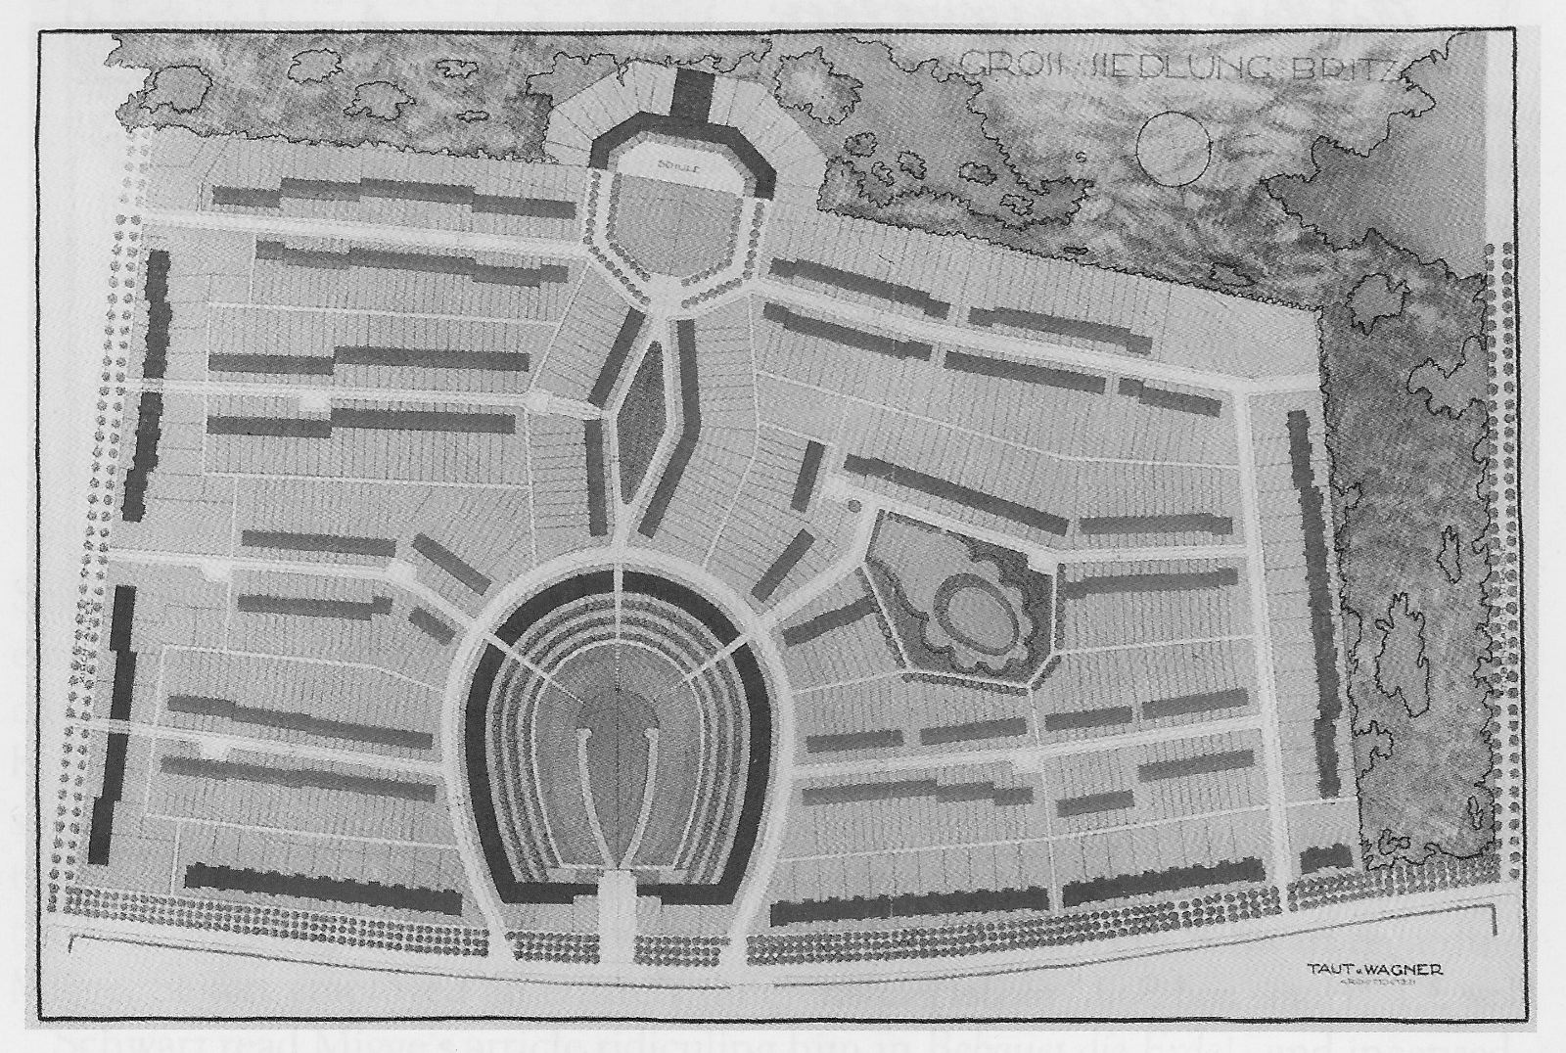
Bruno Taut, Martin Wagner Berlin-Britz (Hufeisensiedlung), 1925-31.
Haney, D. (2010) When Modern Was Green. Life and work of landscape architect Leberecht Migge, London and New York: Routledge, Plate 3.3

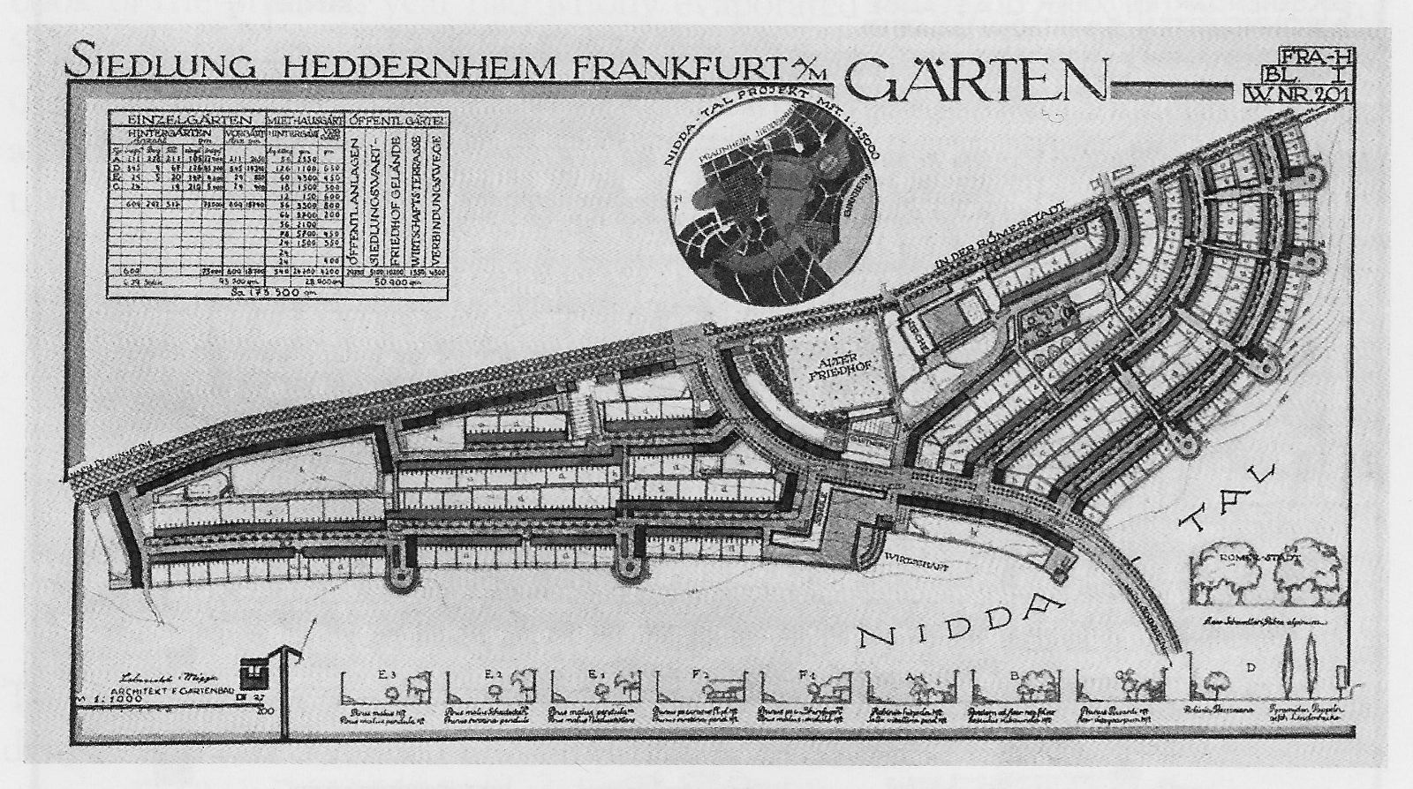
Ernst May, Römerstadt, Frankfurt am Main, 1926-30.
Haney, D. (2010) When Modern Was Green. Life and work of landscape architect Leberecht Migge, London and New York: Routledge, Plate 3.4

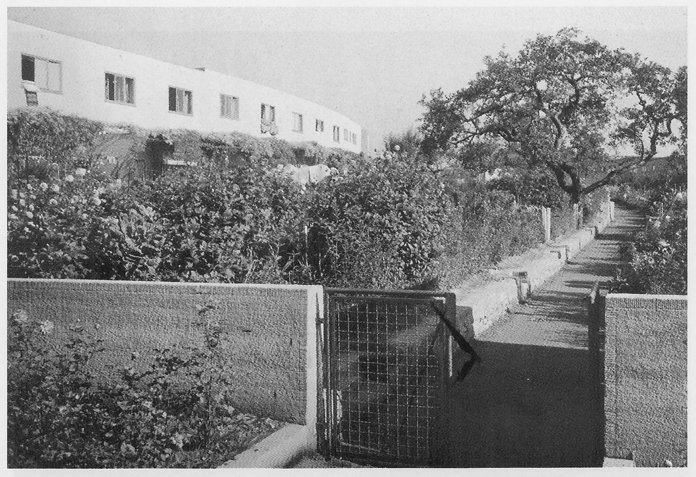
Ernst May, Römerstadt, Frankfurt am Main, 1926-30, garden path.
Haney, D. (2010) When Modern Was Green. Life and work of landscape architect Leberecht Migge, London and New York: Routledge, Plate 3.5

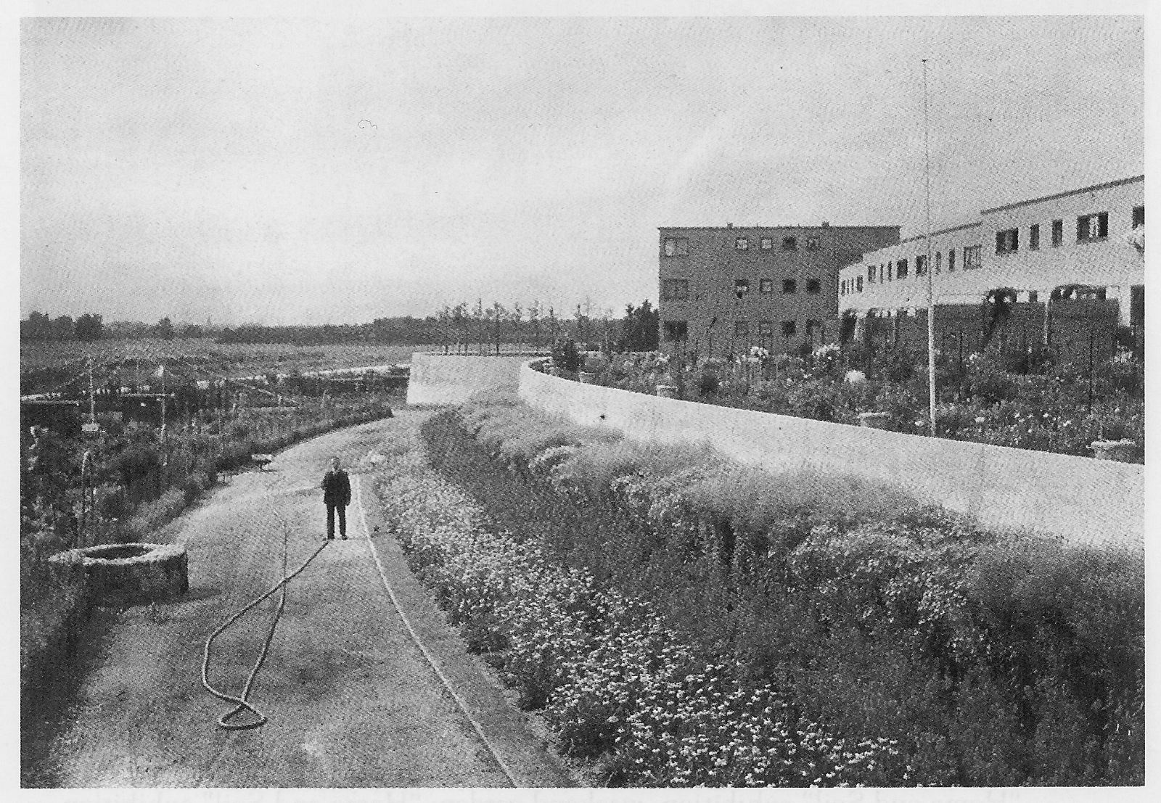
Ernst May, Römerstadt, Frankfurt am Main, 1926-30, garden view.
Haney, D. (2010) When Modern Was Green. Life and work of landscape architect Leberecht Migge, London and New York: Routledge, Plate 3.6

